# Overview

* A system that lets the player raise animals for meat, fiber or other products
* Includes day-to-day care, selective breeding and the raising of livestock.
* Disease control and livestock protection are an integral part

# Animal Husbandry

* A veterinary infirmary is a prerequisite for unlocking animal husbandry
* Various animals can be bought and raised:
  + Bees
  + Cattle
  + Poultry
  + Goat
  + Pigs
  + Horses

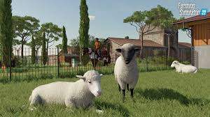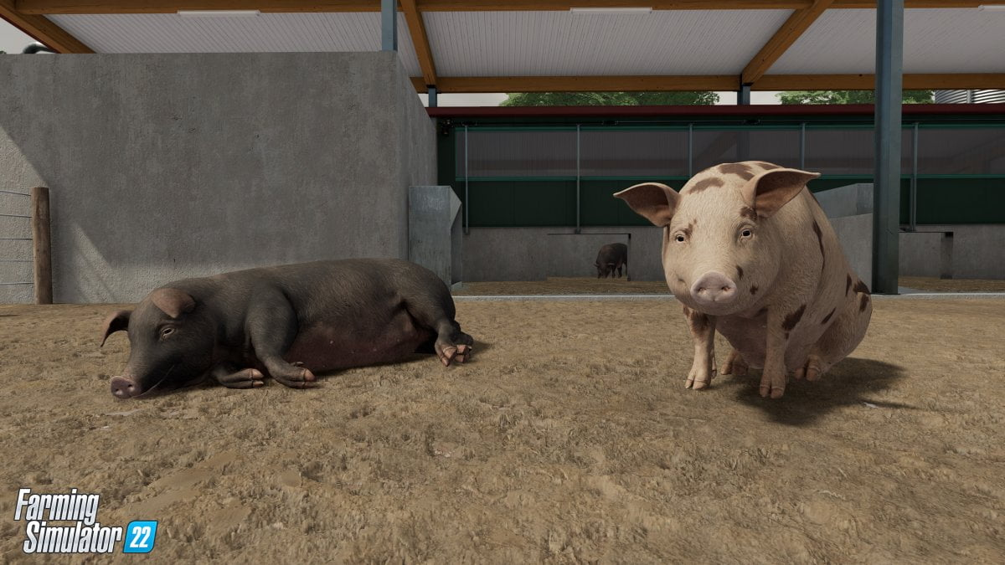

* These animals have to be cared for and may even need individual attention sometimes
* The player has to build proper housing, feeding and security arrangements. Lack of any of these might lead to a runaway animal or a death incase of a predatory attack

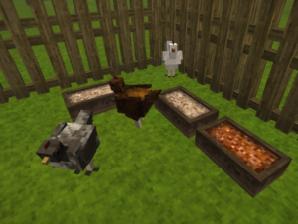

* The player will have various tasks, according to the animals, that need to be done
  + feeding,
  + collecting product (milk, honey,wool)
  + Using animals for farming
  + Medicating
  + Breeding

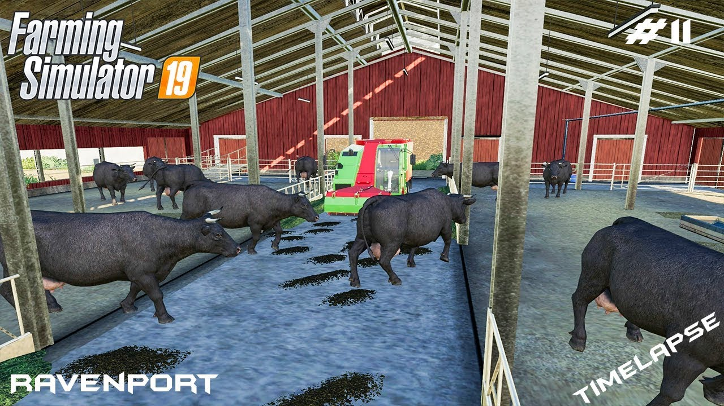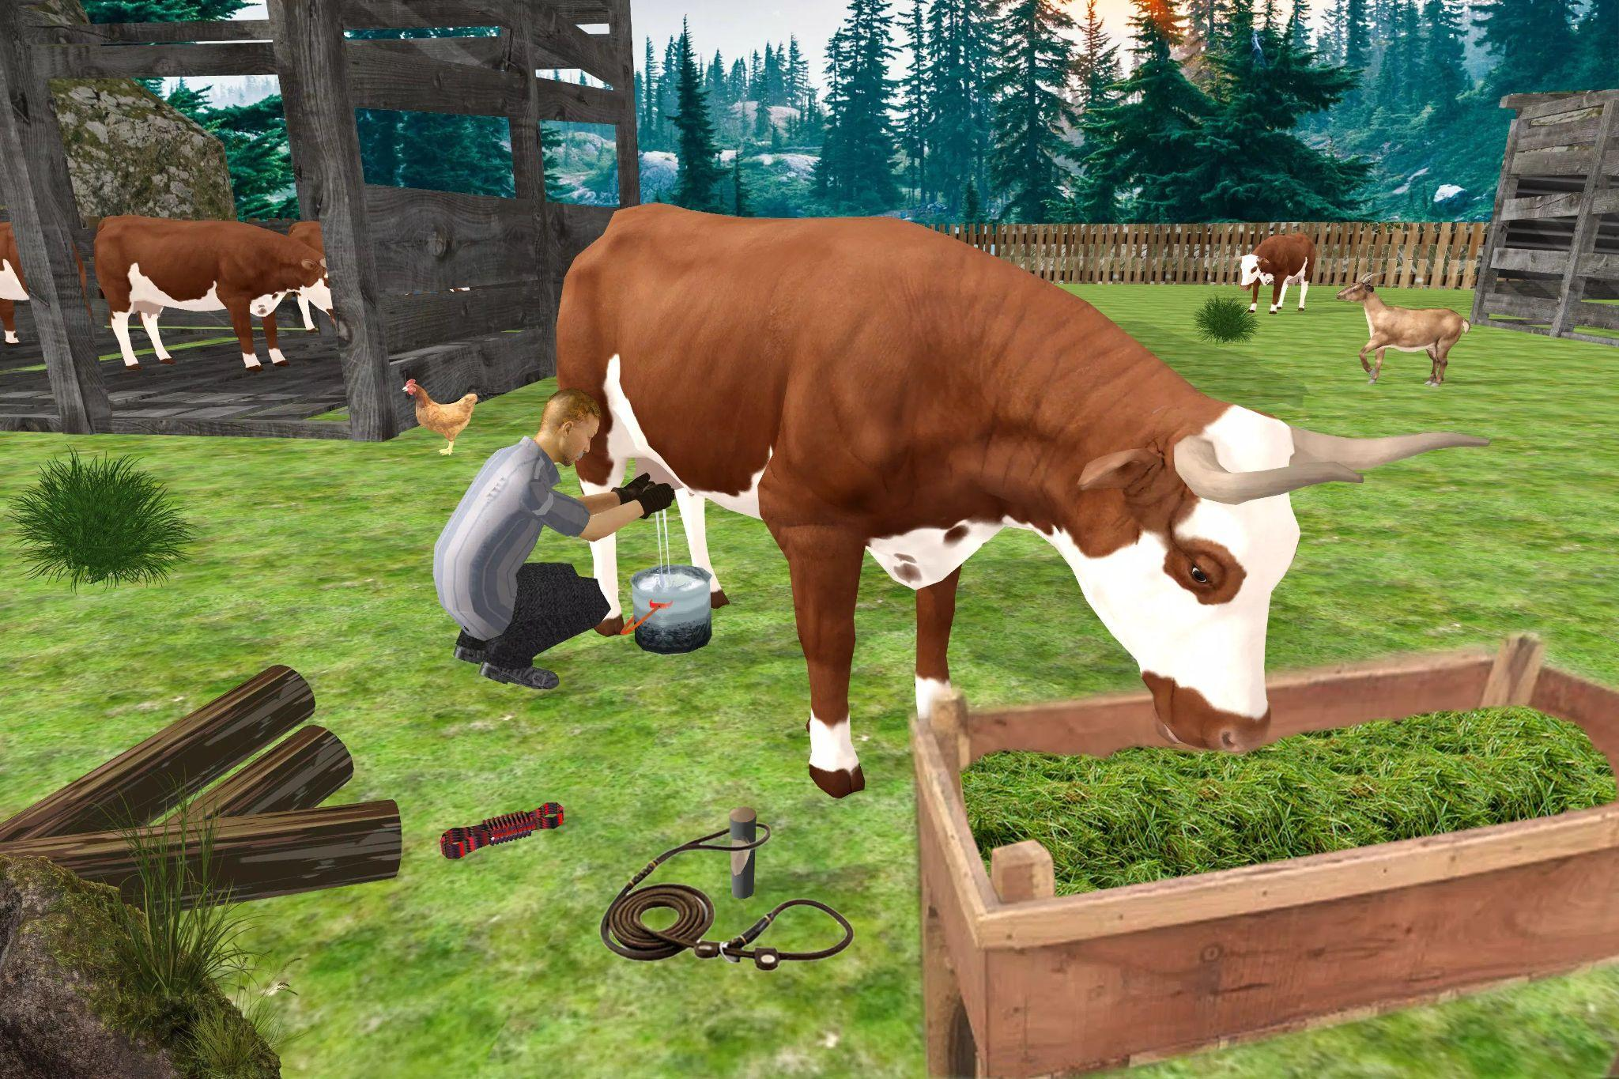

* All of these processes will mine the cryptocurrency
* If these animals get lonely, they might suffer from various problems
* These tasks can be assigned to farmhands.